**Project Proposal**

**Dice and Rules Toolkit**

An application developed to provide concise definitions and examples for the standard terms of Dungeons & Dragons 5th edition

**Submitted to**

Suncoast Technical College

.Net Applications Development and Programming

Instructor: Mr James Hornberger

**Submitted by**

Ben Caruthers

**Introduction and Product Description**

At this point in history it seems we spend more and more of our time finding ways to pass the time. One of the fastest growing sectors within entertainment is surprisingly found in tabletop games. According to analysis of publisher data, one author estimates, “We are currently observing the release of around 3,500 new board games every year, and that number is increasing by around 5.7% each year.” Another report concurs with findings reporting an exponential rise with similar growth projections each year. 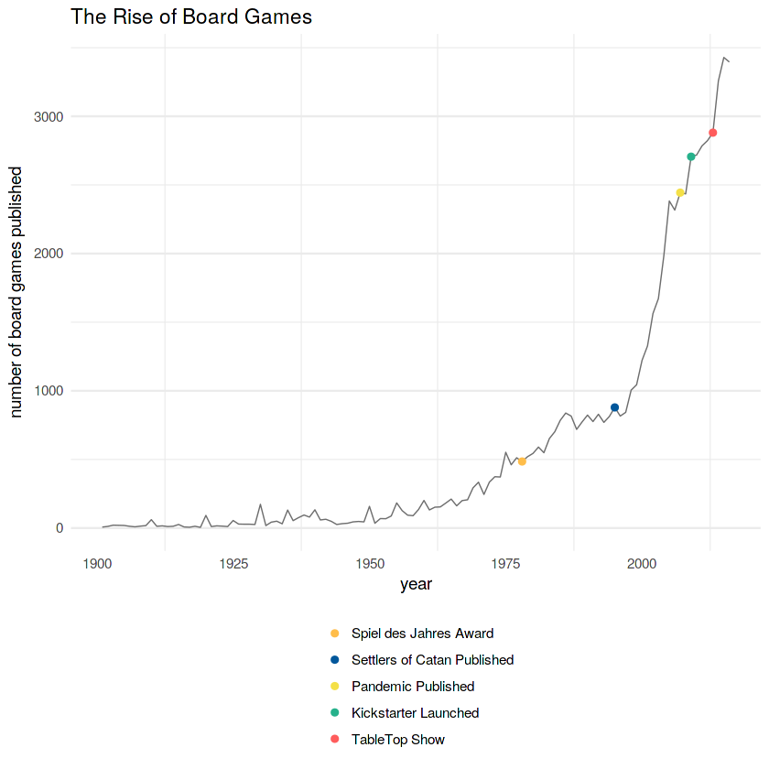

People are not just looking to be entertained, but rather many are looking to be entertained *together*. Tabletop games are rapidly filling this niche and can vary wildly in terms of difficulty, themes and complexity. A not insignificant portion of these games are classified as tabletop role playing games or RPG’s. These are usually focused on cooperative storytelling and rely on both improvisational and numerical systems to determine outcomes for their players. For example, if someone encounters a locked door and wants their character to pick the lock they would roll some dice and add a bonus based on their character’s stats.

Most famous among these types of games is Dungeons & Dragons known colloquially as “D&D” (or “DnD” when a field doesn’t accept non-letter characters) Now in its 5th edition, it is the de facto entry point into the hobby and available worldwide in 8+ languages. The myriad number of rules and key words needed to understand the game have waxed and waned over the years with the current iteration considered relatively easy to pick up. Even with these rules becoming more flexible and systems being simpler to parse the amount of options presented for both a player and DM (dungeon master, someone who runs the game) are, at times, overwhelming. The goal of this project is to provide a simple program able to deliver tools and succinct rules needed to enjoy a game of D&D. The two primary functions of this program include the ability to simulate dice results and provide an easy to navigate display for rules descriptions and examples of their use.

**Project goals of the application/ student**

I would like this project to incorporate multiple windows able to appear within a defined space. This may take the form of several tabs providing different types of information by what is selected--the exact design has not been settled. The user should be able to quickly see the results of searches for rules and be given clear examples of when or when not to apply them. I also will adapt a dice rolling system I have already used a few times at my own home into the program. There may be other small features added such as a turn order tracker as the need arises.

A tentative list of features include the following:

1. Dice roll simulator
2. Definitions of player skills and when they might be used.
3. Definitions of status effects and other keywords.
4. Definitions of actions in combat.
5. Player initiative tracker.

An initial estimate of the product’s time to completion is 2-3 weeks. If successful this program should significantly decrease the clutter of running or playing a game of D&D. If you don’t have all the dice needed, you can simply click a button to get a random number in that range. If you don’t know what a word means, you can simply click on it to expand a small window with an example.

As far as an overview of how I intend to develop and implement the application, I hope to just work on one small feature at a time. If the scope of the project becomes too large, or a feature too time consuming to complete it will be left as a work in progress. Conversely, some features may end up being added if this takes less time than predicted. I will need to become comfortable manipulating more than one window on the screen at once and learn how best to present segments of my data.

**Tool Requirements**

This program will be developed entirely in visual studio and designed to run as a simple .exe file on Windows. For rules data I will refer to the source reference documents (SRD) of 5th edition D&D as well as other advice collected around the web for the game in matters subjective. Any interested client will simply need a computer running a modern Windows OS.

**Project Conclusion**

Once again the goal of this project is essentially to produce dice simulation / an electronic reference sheet to consult for quick questions. I do not intend to make this program a platform to store and save personal notes, characters, or campaign data. There is also additional data for the game I do not own and will not add here such as monster statistics, proprietary setting info, and player character options.

If this program proves successful, I may consider including graphics and animation to its features. Instead of a standard form background one might have an ancient weathered tome with individual tabs becoming pages users click on -- dice rolls might have an animation and image of their results rather than simply filling a label etc.

**Deliverables, Deployment and maintenance - Ideal and Otherwise**

This will be distributed via a usb drive, likely only between here and my house. I might also look into creating accounts on file hosting web services to store this program and show some friends. As this is primarily made for my own and my close friend’s uses I do not foresee any end user support or updating. The marketing budget will also be ~$0.00 and that entire department ~~has been fired~~ is now free to pursue other employment opportunities.